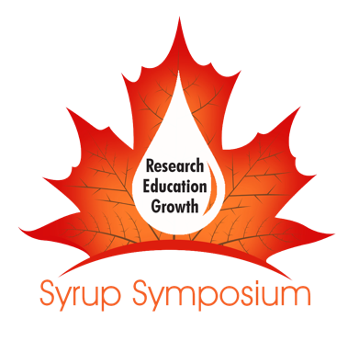
The Second Southern Syrup Research Symposium:
Making it Work in the Southern Tier

In September 2018 the West Virginia Department of Agriculture hosted the Southern Syrup Research Symposium to focus attention on research and extension needs to expand the tree sap industry in “the southern tier” of syrup producing states. A lot has happened since then. On June 19th and 20th we will be reconvening the Symposium at WVU in Morgantown WV to take stock of where we’ve come and shine a light on where we need to go. Join us for updates on research and development grants our region has received, to hear from researchers on problems and opportunities specific to our region, and to take part in discussions on the adaptations sap and syrup producers are making to increase yields and maintain quality.

The Symposium will be preceded by a maple syrup quality control and grading workshop on Friday and include Saturday afternoon workshops on innovative maple cooking and value -added processing.

The Symposium is hosted by West Virginia University and co-sponsored by Ohio State University, The Future Generations University Maple Program, and Virginia Tech. Funding provided by a USDA 2017 ACER Access grant.

For more information contact:

Jamie Schuler
WVU Division of Forestry
jamie.schuler@mail.wvu.edu
870-723-9378

